BUFFY

THOMPSON

PHOTOGRAPHY

Wedding Photography Packages

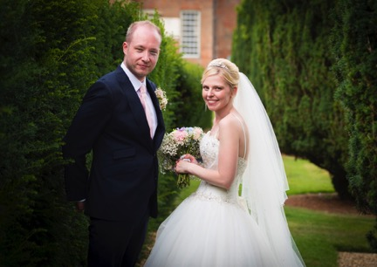
Thank you for considering me as your potential wedding photographer and hopefully all the information you need on prices and terms will be contained in this document. However please do not hesitate to call or email me with any additional queries you may have.

Your wedding is one of the most important days of your life, but it will move incredibly fast and you need a good photographer to capture every aspect in a way that will bring it back into sharp focus each time you look through your photos.

I want you to remember this day forever in pictures, as the day your marriage began with the love of your life and therefore every photo should reflect the importance of this and the love that is there.

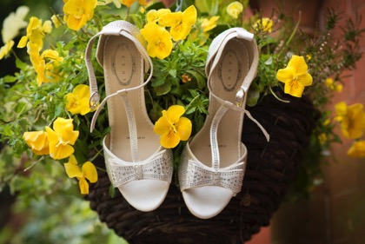
By the time you get to your big day you will hopefully know me a little already and I will have made it a priority to know you both so that whatever ‘vision’ you have of your wedding is mirrored in the photographs you get back. I listen to what you want. This is about YOU both and not about me showing off my photography. I am happy to stand back and be utterly unobtrusive, but equally if you are feeling courageous and want to try some wacky things I am totally up for that too.

If you like my style and think I could be the right photographer for your big day, I would love to hear from you.

I offer four main packages to choose from, but if your requirements are different, or you would like any of them tailored to your own needs, please call or email me to discuss the options.

Just so you know a little about me…. I am in my early 40’s and happily married to Simon who I met on Match.com after 3 days of registering. Two weeks later we met and I removed my profile from Match, which is fairly unusual I know but it just goes to show that magic can happen! We have a beautiful daughter, 2 rescued dogs and 4 rescued cats. I absolutely love being a photographer and it is what I have wanted to do all my life, so after a fairly mixed career in various different sectors I finally took a leap of faith and am delighted to say that I haven’t looked back since. We live in the gorgeous Suffolk countryside, which is a constant source of inspiration.

I do all kinds of photography but weddings are my favourite! You can’t beat being around a large group of very happy people and every single one is a unique joy and privilege to be a part of. I would love to join you at the beginning of your own adventure and look forward to hearing from you.

PACKAGES AND PRICES

These packages are designed to be straightforward with no hidden costs or unexpected charges. With each package you get ALL the photos from the day fully-edited on a USB (as high-resolution print ready files) in my own gift box, so you don’t have to choose only a limited number or pay for extra photos. Once you have the USB you are free to get your photos printed anywhere, produce your own album, photobook and framed prints. But you can also ask me to do it for you if you prefer and I have access to some amazing products that are only available to professional photographers. All packages include a planning phone call or meeting where we will go through the finer details and photography plans of the day as well as, of course, my help and advice regarding your photos and/or albums, before and after the wedding.

N.B. There is a discount on prices quoted here if your wedding is not on a weekend, public or bank holiday.

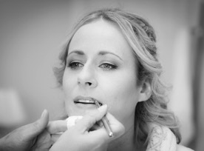
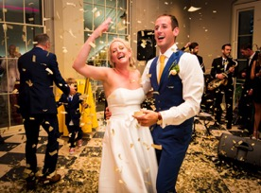
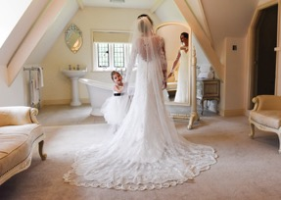

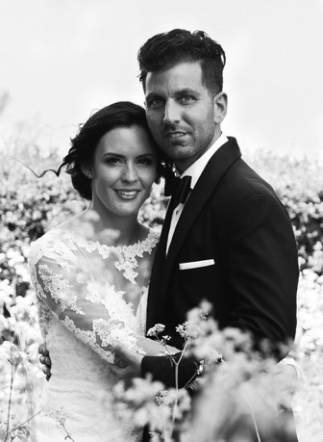
Velvet:
4 Hour Coverage + Fully Edited Photos on a USB - £800 (discount £700)

This is a great package if your budget is lower but you still want the important part of your day captured. I can cover a great deal in this condensed package – the whole ceremony, groups and family shots, natural shots of your guests having a fabulous time and beautiful portraits of the two of you as a married couple.

I arrive 1 hour before the start of your ceremony and then stay for about two hours afterwards but in total I am with you for 4 hours.

You will receive all the photos as high-resolution fully edited JPEGs on a USB in my own gift box, which you can then share with family and friends.

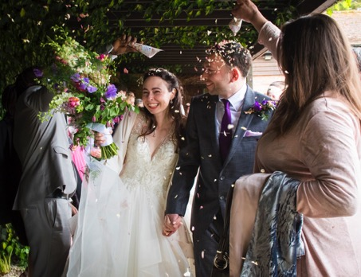
Satin:
Pre-wedding Shoot + All-day Coverage + Fully Edited Photos on a USB – £1,200 (discount £1,050)

Full coverage of your day: This means I will be joining the bride getting ready and stay until approx. an hour after your first dance which is generally about 9 Hours but you can always add on extra time if you need to for fireworks etc.

Pre-wedding photo shoot: We’ll meet a few weeks before the wedding at the venue or a location you choose. This is a relaxed session to get you used to both my camera and me and to chat about the details of your day. You’ll also get some lovely ‘engagement’ shots of you both to keep.

As before you will receive all the photos as high-resolution, fully edited JPEGs on a USB stick in my own gift box.

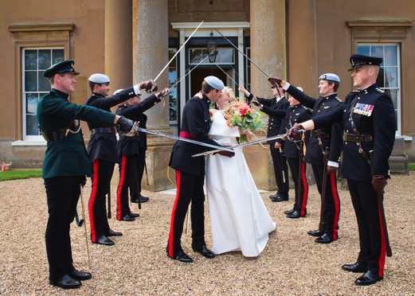
Lace:
Pre-Wedding Shoot + All-day Coverage + Fully Edited Photos on a USB + Exclusive Folio Fine Art Photobook
– £1,650 (discount £1,500)

This is the same as the Satin package but with this package you also get a gorgeous, 30 page spread Folio Fine Art Photobook, 12” x 12” and containing up to 80 of your favourite prints. Photobooks generally are not quite as luxurious as albums, but these ‘Fine Art’ ones are an exception!

The Folio Fine Art Photobook is really stunning. They are handmade in the UK and exclusively available to professional photographers. You can look at their website here: https://www.folioalbums.com/products/

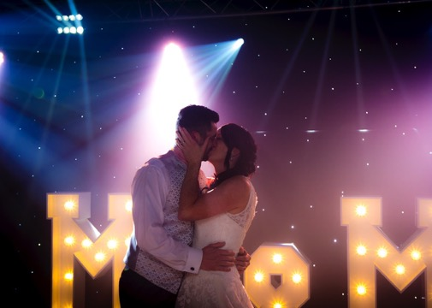
Silk:
Pre-Wedding Shoot + All-day Coverage + Fully Edited Photos on a USB + Exclusive Folio Hand-made Leather Matted Album
– £1,900 (discount £1,700)

As with the previous two packages I will be there all day for you from the bride (and groom) getting ready through to your first dance (and beyond) and all points between.

For the Silk package in addition to this and the pre-meeting shoot you also get a stunning handmade leather 30 page spread Folio Matted Album, 12” x 12” and containing up to 80 of your favourite prints.

The Folio Matted Leather-bound Album is one of the highest quality on the market, and the price reflects this. They are handmade in the UK and exclusively available to professional photographers. You can look at their website here: https://www.folioalbums.com/products/

Add Ons:
1. Engagement Shoot
If you want the would like a session with me to celebrate your engagement a one hour+ shoot incl. a USB stick with the images will be £250. This can be at a location of your choice i.e. beach, park, your own garden etc.

2. Trash the Dress
Once the wedding is over rather than consigning your dress to it’s plastic bag and the cupboard why not do a location shoot where you can metaphorically ‘trash your dress’ (you don’t actually have to ruin it!) and do something a little more adventurous. Lying on the beach as the waves roll in. Walking through a woodland in the dappled light. Sitting on the tube surrounded by commuters. Riding a horse. Playing with the dogs. Doing the washing up. If you’d like to add something a bit different to your wedding album have a chat with me… whatever your idea is I am sure we can do it.

Cost will possibly depend on the location and what you want to do but as above one hour+ will be about £250 plus the images on a USB stick.

3. Second Photographer
I have a great friend and colleague I have worked with for weddings and other events and if your wedding is a particularly big one with a lot of guests and a lot going on you may wish to consider having a second photographer. Please ask me about this if you think you would be interested.

4. Additional albums
You can add additional photobooks or wedding albums to any of my packages.

FAQs:
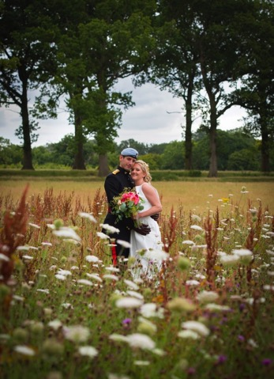
How do we make a booking and what happens next?

Let me know you’d like to go ahead and I’ll ask for some details so that I can prepare a contract. I’ll send this to you for checking and signing along with an invoice for 50% of the fee. Once this is paid and the contract signed your date is secured. I will then be in touch about meeting for a pre-shoot (if this is part of the package) and nearer the time will be in touch to find out all the details of your day, timetable, list of group shots etc. You can call me any time or drop me an email and I will always respond quickly.

Can we remove the Pre-Shoot from the package?

Of course if you really want to… however I will always try and talk you out of this! Mainly because it is so important for all of us to get used to each other before the big day and this is the best way to do that. I get to see how you both behave in front of the camera and you get to see my style. Then on the day it will be so much more relaxed because you have done it all before. This pre-shoot is especially important for those of you who hate having their photo taken!

Do you ever use an Assistant?

I tend not to as I prefer working on my own. If you need a second photographer I have a friend I often work with who is amazing, but I don’t actually need an assistant. Very occasionally I will get asked by a student or via a charity if someone can come and shadow me for an event to learn the trade. If that happens I will of course ask your permission first.
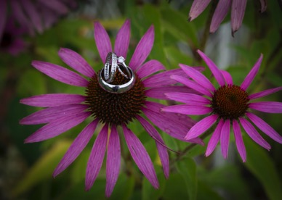
What happens if the weather is bad?

You still get amazing photographs! Believe me weather is nothing to worry about and we can always find a way to get beautiful shots come rain or snow…. Also I guarantee you will neither notice nor care on the day as you will be in a little floaty bubble of happiness that no weather can burst.

Can we request specific types of shots?

Of course and we will discuss all of this in full once you have booked me.

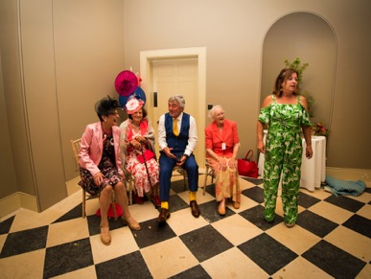
How many photographs will we get?

This depends partly on how long I am with you and partly on the number of guests you have and what happens during the day. A Velvet package will normally produce at least 3-400 photographs however as a rough guide and a full day package will be at least 6-700, possibly more.

How long before we can see our photographs?

I always do my best to get photographs edited within 3 weeks at the most.

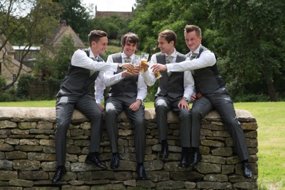
Are you insured?

Absolutely! I am also DBS checked. If a new venue I have not worked at before requires copies of my insurance that is fine, I am happy to provide it.

Do you charge for travel?

If you have booked me all day I’m happy to travel at no extra charge within most of East Anglia. If your wedding is outside of this area I may need to add a travel charge, depending on the distance or if you only want me for the 4 hour package. If it requires me to stay overnight somewhere this would also be added as a charge.

Do we need to provide you with any food:

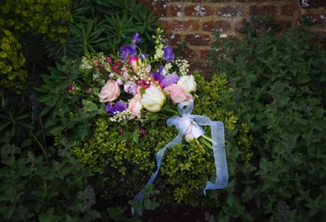
Yes please but only for the Satin, Lace and Silk Packages. I will require a meal with the rest of the staff at some point in the day please – it is a long time to go with no food otherwise!

Are you able to help us with any other suppliers?

Yes of course and I have worked with a number of lovely people in this area. I also have a wedding supplier guide on my website so do take a look there first and if you still can’t find what you need just ask.

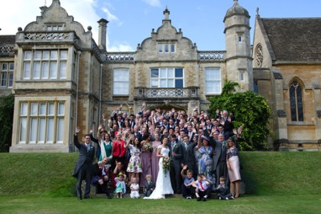
What happens if you are ill and can’t make it?

I hope this will never happen and so far it hasn’t, but in the event that I am hospitalized or some other catastrophic event occurs I will immediately try to secure another photographer for you through contacts locally and I will also refund you the full amount of money, of course.

We don’t want any of our images appearing online, is that ok?

That is absolutely fine. A handful of clients have asked me not to blog about their wedding or to use their photos for marketing and I will completely respect your wishes if that is the case although I do ask that you please let me know this in writing so we are very clear about it.

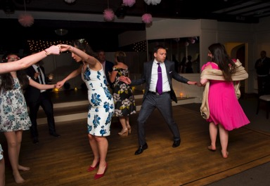
What equipment do you use and what happens if it breaks?

I use two Nikon D750 camera bodies and a variety of lenses and other equipment. I have two cameras because it allows me to use two different lenses at a time but also because it means I have a back up if one of them has a technical problem. I also back up my photos as I take them. I guess I don’t want to tempt fate and say that nothing would ever happen to stop me working but I have covered every likely possibility for things to go wrong, so I feel fairly certain that my equipment is capable of coping with most eventualities.

Do you watermark your photos?

No I never do this with clients. The only time I ever watermark is for marketing purposes, but this would not affect your photos.
Terms and Conditions

50% of the fee is payable up front. This is the booking fee and means that I wont be able to book anyone else for your specified date and time. The remainder is due 1 month before your wedding day.

Buffy Thompson retains copyright to all her own work and can use any photos on her website or in any of her marketing materials or as part of a blog etc. If you do NOT wish your photographs to be used in this way or shown in any form of social media, please make sure you request this in writing before the day.

Any photographs you pay me to take and which you are then given are licensed to you for your own private use and you may of course share these with friends and family BUT if you wish to use any photographs taken by me for commercial purposes you must seek permission. Attribution-NonCommercial 4.0 International (CC BY-NC 4.0)

Buffy Thompson will not provide RAW files, only edited High Resolution Jpegs.
